Workforce Intelligence Summary
Rural adult social care workforce information
2018/19

Source: NMDS-SC information as at March 2019

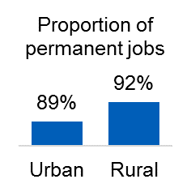
This summary report compares the adult social care workforce across rural and urban locations. Rural and urban geographies were determined by the Office for National Statistics definitions, which match postcodes to rural and urban categories. This information was then paired with National Minimum Dataset for Social Care (NMDS-SC) information, as at March 2019, to analyse differences between workforces in rural compared to urban locations. Please note that the information in this report is for the independent sector only, and is raw, unweighted NMDS-SC data. Therefore, this does not have 100% coverage of the sector.

  - Employment overview
A slightly higher proportion of rural workers (92%) had permanent contracts compared to urban workers (89%). However, all other types of contract were relatively similar across both types of area.

Zero-hours contracts were less prevalent in rural areas, with 19% of jobs on zero-hours contracts compared to 25% in urban areas. This, and the larger proportion of permanent positions, suggests there may be better job security in rural areas.

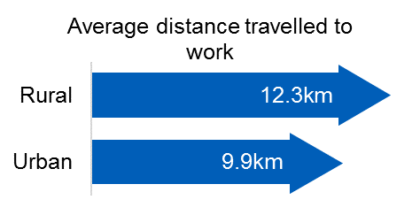
However, a key factor affecting the likelihood of a worker leaving their role was the distance travelled to work. Skills for Care models found that this could have more of an influence on a worker’s propensity to leave their role than both contract type and zero-hours contracts. In rural areas, workers travel on average 12.3km to their place of work. In urban areas, this 2.4km shorter on average (9.9km). It should also be noted that this is from the worker’s home to their place of work. This does not include travel between people using services in, for example, a domiciliary care setting.

  - Recruitment and retention
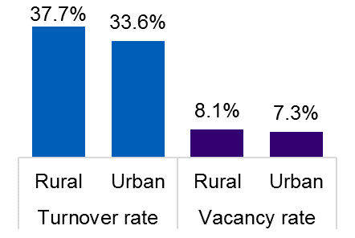
Turnover rates were higher in rural areas (37.7%) compared to urban areas (33.6%). Vacancy rates were also higher, at 8.1% and 7.3% respectively. This suggests that rural services were struggling to retain current staff and recruit new staff. One factor that may have influenced this was the proportion of working age population in comparison to those aged 65 and over. Unemployment rates and availability of alternative work could also affect the vacancy rates within adult social care.

Around 64% of workers were recruited from within the adult social care sector in rural areas. This proportion was slightly higher in urban areas (69%). The average number of sickness days was also lower in rural areas (4.7 days) compared to urban areas (5.1 days).

  - Demographics
The average age of a worker in a rural area was similar to those in urban areas (43.2 years old compared to 43.0 years old). There were an equal proportion of male and female workers across both rural and urban areas (17% and 83% respectively).
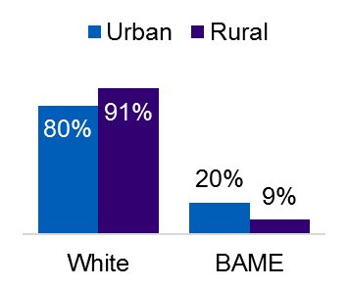
In rural areas, there was a higher proportion of workers identifying as having a white ethnicity (91%) compared to urban areas (80%). This difference was largest for workers identifying as having black ethnicity. Around 10% of workers in urban areas were black, compared to 3% in rural areas.
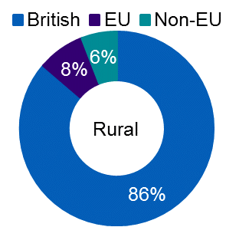
There was a slightly higher proportion of British workers in rural areas (86%) compared to urban areas (84%). Around 8% of workers in rural areas were from the EU. In urban areas, this proportion is slightly lower at 7%. However around 9% of workers in urban areas were from outside of the EU compared to 6% in rural areas.

Skills for Care are continuing to monitor the potential impact of Brexit and future immigration policy across the adult social care workforce.

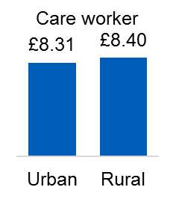
  - Pay
The average hourly rate for a care worker in the independent sector was £8.40 in rural areas compared to £8.31 in urban areas. Whilst the average hourly rate was higher in rural areas in all regions except London, it should be noted that these workers travel much further on average as aforementioned.

This pattern was similar across most job roles, excluding senior management – urban managers earned £34,700 a year on average compared to £33,600 in rural areas.

  - Qualifications and training
The care certificate – which is aimed at direct care workers that started in the sector since January 2015 – had similar engagement across rural and urban areas (49% and 48% respectively for direct care workers). The proportion of the workforce with a social care qualification was also similar across rural and urban areas (51% and 52% respectively).

As a result, there is little evidence that overall qualification and training of the workforce differs by rural and urban settings.

