An Analysis of the Rural Index of Deprivation with Respect to Lincolnshire, Norfolk and Devon.

John Shepherd
Emeritus Professor of Geography
Birkbeck University of London

1 Introduction
Using the County of Lincolnshire as a case study, a previous note described a comparison of the Rural Deprivation Index (RDI) produced in the Norwich Medical School at the University of East Anglia, with the official Index of Multiple Deprivation (IMD). The RDI is the first comprehensive attempt to create an index of deprivation focused specifically on the rural environment.
This note extends the Lincolnshire exercise by adding the counties of Norfolk and Devon as comparators between the IMD and the RDI. The method of comparison is the same i.e. via tables and maps rather than formal statistics or a ‘deep dive’ into the concepts and variables underlying the RDI. The text for Lincolnshire is essentially the same as in the previous document. The presentation of the results for Norfolk and Devon is more succinct.
The addition of Norfolk and Devon to the analysis is at the request of interested individuals who saw the initial paper. Together the three counties add to the analysis in a number of ways, especially as:
- they are in different regions/LEPs,
- they are typified by different settlement structures, especially in relation to the number and dominance of cities and major towns they contain, and
- they have somewhat different rural economies, especially regarding the role of primary industries and tourism in overall economic activity.
These and, no doubt, other factors would have to be taken into account in a deeper, more substantively based comparison of the RDI with the IMD. The present paper should therefore be seen as a basis for discussion on the need for and nature of an indicator of deprivation in rural areas.

2 The Index of Multiple Deprivation 2019
The Index of Multiple Deprivation (IMD), the most recent update of which was published in September 2019 is a summary of a number of measures expressive of deprivation in geographic areas. The most detailed geographic level published is that of Lower Super Output Areas. The IMD presented at this and higher geographic scales is of central importance in supporting the allocation of many central and local government funding streams. It is also the basis for the analysis of a range of policy outcomes.
The IMD has been criticised by some non-governmental bodies and various interest groups as being excessively oriented to urban concerns and, as a result, biased against rural geographies. The main criticisms of the IMD insofar as it relates to rural deprivation, although interrelated in various ways and, to some extent, reinforcing each other, are:
- it focuses on concentrations of deprivation in small areas, whereas rural deprivation is more scattered geographically, especially among small rural towns, villages and dispersed settlements,
- many of the measures of which the IMD is comprised are urban oriented inasmuch as they are easily counted data whereas some rural concerns (e.g. forms of agricultural crime or some aspects of health and welfare), are not reported at all or are under reported, and
- although access to services and housing measures are included in the IMD they are not appropriately measured and/or are given less weight in comprising the measure than the traditionally urban measures that are included.
In response to such criticisms the Norwich Medical School (NMS) at the University of East Anglia has produced a Rural Deprivation Index (RDI). Analysis of the IMD 2019 domains against the Rural_Urban Classification (RUC) for England, using Norfolk as a case study, increases the number of ‘deprived’ LSOAs and suggests, for example, that LSOAs in the RUC class ‘rural villages and dispersed’ are considerably more disadvantaged on the ‘Geographic Barriers’ sub domain than other RUC classes. Rural Village and Dispersed LSOAs were also found to be more disadvantaged on the ‘Education, Children and Young Persons’ sub-domain.

3 The Components of the NMS Rural Deprivation Index

The NMS RDI is based upon a similar methodology to that of the IMD but with different, nominally more ‘rural oriented’ variables as shown in the Table 1. Five of the eight variables selected for inclusion in the RDI are taken from the IMD which ensures some continuity of concept and measurement with the latter.

In the case of its ‘Locality related deprivation dimension’ the RDI uses the DfT ‘Journey Times to Key Services’ data rather than the IMD ‘Geographical Barriers’ data which are based upon road distances rather than time travelled. The DfT data, on the other hand, are modelled rather than surveyed data. It is not clear how these data are handled in the RDI i.e. how the measures for the ‘eight essential services’ are aggregated or how the typically ‘low digit’ measures are aggregated. S ‘Spatial Scale’ dimension – essentially, a measure of the variability in bad/very bad health by household in Census Output Areas within LSOAs – was also proposed and assessed, but was excluded from the RDI following assessment of its performance in the data aggregation process.

Table 1 Indicators used in the NMS RDI
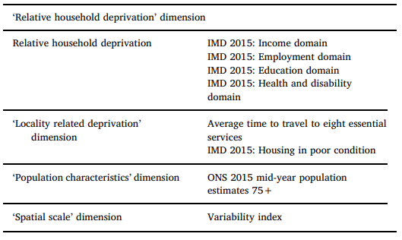
Source: Burke A and A Jones, The development of an index of rural deprivation: A case study of Norfolk, England, Social Science and Medicine 227 (2019) 93-103, p 97
The methodology for combining the measures within the RDI was essentially the same as that for the IMD - using principal components analysis with ranking, weighting and summation of scores to produce a composite index. Various score weightings were applied and intensively tested against their distribution across RUC categories and compared with the distribution when the IMD was used. The validity of the outcomes was measured against variables deemed ‘relevant to rural deprivation’ not included in the IMD and mostly associated with rural health issues.

4 The NMS Norfolk Case Study
A scatterplot (scaled to a zero origin) of RDI scores against IMD 2015 scores for the County of Norfolk reveals, as expected given that is main component variables derive from the IMD, a close correlation between the two measures (Graphic 1).
From a visual assessment of the scatter diagram the RDI appears to be identifying two contrasting elements in the rural settlement pattern of Norfolk:
“The RDI was plotted against the English IMD 2015 ... using LSOA ranks, where rank 1 is the most deprived; deprived LSOAs are therefore shown near the origin. The most deprived urban LSOAs using the IMD are generally less deprived using the RDI as they sit above the line of equality. LSOA in the ‘Rural town and fringe’ classifications are mostly more deprived when using the RDI. For the ‘Rural village and dispersed’ classification, deprivation is increased for those LSOA that are most deprived using the IMD (a number of ‘Rural village and dispersed’ LSOAs sitting below the line of equality near the origin”. Burke and Jones, 2019, page 99.
On the one hand there are the larger and, generally, locally more concentrated settlements. These tend to be identified as ‘more deprived’ relative to what they are under the IMD. On the other hand there are smaller, locally more scattered/low density settlements which tend to be identified as ‘less deprived’ than according to the IMD. Urban settlements seem to be more evenly scattered around the ‘line of equality’ and hence, presumably, similarly represented by both indicators of deprivation.

Graphic 1 Scatterplot of IMD Scores and RDI Scores with a Zero Origin
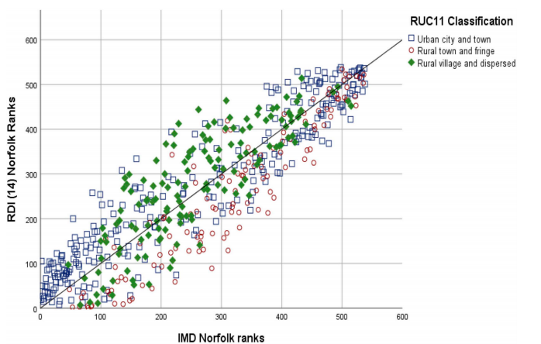
Source: Burke A and A Jones, The development of an index of rural deprivation: A case study of Norfolk, England, Social Science and Medicine 227 (2019) 93-103, p 101.

5 Extending the Norfolk Case Study
In the remainder of this note we compare the performance of the IMD with the RDI for three counties on a similar (i.e. tabular rather than graphic) basis. The counties are Norfolk, Lincolnshire and Devon.
The focus of the comparisons are the deciles of highest deprivation as used in many policy applications of the IMD and on the more extreme changes between the two measures of deprivation in terms of deciles. Maps of change between the two indicators may facilitate discussion based upon local knowledge. The data are for the 2019 versions for both the IMD and the RDI so the results are not directly comparable with the NMS Norfolk case study.
The interpretation of the results for Lincolnshire are done in more detail than for those of Norfolk and Devon. The presentations are identical but only salient points for Norfolk and Devon are mentioned as a basis for further discussion.

Case Study 1: The County of Lincolnshire

- The Rural Settlement Structure

The distribution of the number LSOAs classified by the RUC, comprising Lincolnshire and the associated 2019 small area Population Estimates, are shown in Table 2. These provide a first basis for assessing the impact of the RDI compared with the IMD.

Table 2 The Distribution of Numbers and Population of LSOAs by Rural Definition
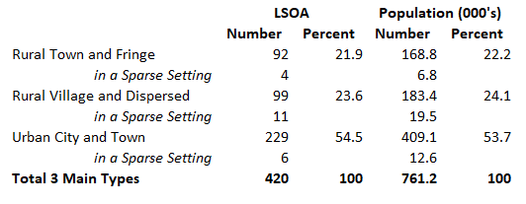
Over half of LSOAs in Lincolnshire are classified as ‘Urban City and Town representing just over half of the population. The similarity in the number and hence (because of the way LSOAs are constituted) the total population of LSOAs is also of note indicating a (very) rough equivalence between more and less scattered types of rural settlement across the county. However, only 21 LSOAs are categorised as being ‘In a Sparse Setting’. For the purposes of this analysis these have been incorporated into their respective ‘non-sparse’ types.

(ii) Comparing the Decile Distributions of IMD and RDI LSOAs
Table 3 shows the distribution of the three rural types of LSOA against MDI 2019 ranked scores grouped into the two most disadvantaged deciles and into five quintiles. This is the most elementary presentation of the way in which the IMD may be said to be biased towards urban settlements. Only 10 LSOAs appear in deciles 1 and 2 (i.e. 6 percent of all rural LSOA types) compared with 55 (32 percent) of urban LSOA types.

Table 3: The Distribution of IMD 2019 LSOA Ranks by Settlement Type
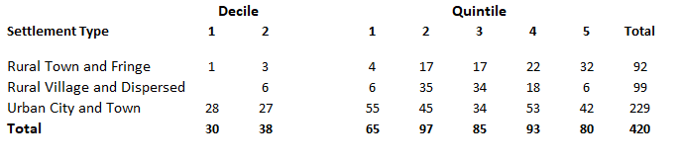

Table 4 shows the same distributions based on the RDI. Overall, there is an increase of 41 LSOAs in decile 1 and of 16 LSOAs in decile 2. These are predominantly ‘rural’ LSOAs – 25 in the case of Rural Town and Fringe types and 24 in the case of Rural Village and Dispersed types. Note, however, that compared with the IMD the RDI has actually increased the number of Urban City and Town LSOAs appearing in Decile 1 – from 28 to 44. This may seem counter-intuitive given the rationale of the RDI.

Table 4: The Distribution of RDI LSOA Ranks by Settlement Type
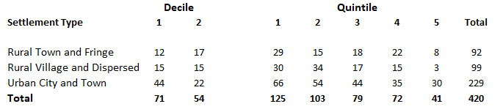

Mapping provides a basis for generalising comparisons spatially and, potentially, for engendering explanation via local knowledge. Map L1 shows LSOAs classified by the most deprived deciles 1 and 2 of the IMD 2019. Map L2 shows the same deciles for the RDI for the same year data. Within Lincolnshire IMD Deciles 1 and 2 are confined to the East Lindsey coastal strip formed of two parts at the core of which are LSOAs classified as ‘ Urban City and Town’ on the RUC – a northerly group focused on Mablethorpe and a more extensive group around Chapel St. Leonards, Ingoldmels, Skegness. There are no ‘most deprived’ rural LSOAs elsewhere in Lincolnshire. There are no LSOAs in Decile 1 among the Rural Village and Dispersed settlement class on IMD 2019.

RDI 2016, in clear contrast, appears to spread its two most deprived deciles further into East Lindsey contiguous with the IMD core groups (which it replicates). These are mainly ‘Rural Village and Dispersed’ LSOAs. Perhaps most significantly, RDI 2016 identifies contiguous groups of ‘most deprived’ (by its own lights) LSOAs in Boston and South Holland as well as some grouped and isolated LSOAs in North Kesteven and West Lyndsey. In comparing the IMD/RDI outcome on the basis of these maps, however, we are aware that the size and shape of LSOAs masks the underlying detailed reality of rural settlement.

(iii) Significant Shifts in the Decile Distributions

The shift from one adjacent decile category to another may be marginal depending upon the rank of an LSOA within deciles. A shift from Decile 2 to Decile 1 could, for example, involve only one change in rank. Table 5 presents significant shifts between one decile and another, specifically a 2, 3 or 4 deciles shift up or down the scale. In the table ‘less deprived’ means a shift to a lower rank, whilst ‘more deprived’ means a shift to a higher rank between the IMD and the RDI.

Table 5: Significant Shifts in Deciles from IMD to RDI

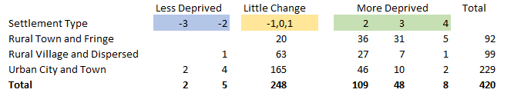

The majority (165/420) of significant changes are in the ‘more deprived’ group 56 of which change by 3 deciles or more. There are only 7 ‘less deprived’ LSOAs. Of the 165 ‘more deprived’ LSOAs, the majority (72), are in the Rural Town and Fringe settlement type compared with 35 in Rural Village and Dispersed LSOAs. No fewer than 58 of the ‘more deprived’ group – 35 percent of this group - are Urban City and Town LSOAs.

Map L3 shows significant shifts in IMD/RDI deciles by LSOA RUC classification. A number of ‘worsening’ shifts of LSOAs are located in the Boston, South Holland and North Kesteven local authorities. These shifts involve both new ‘deprived’ LSOAs compared with the IMD and the ‘intensification’ of existing ones. Deprived LSOAs on the East Lindsey coast, on the other hand, are not, in most cases ‘worsened’ by their appearance in the RDI.

Finally, as Table 5 shows, there are 7 occurrences of LSOAs becoming ‘less deprived’ between the IMD and the RDI, 6 of which are classified as ‘Urban City and Town’. Five of these are within the Lincoln Built Up Area (Map L3).

Case Study 2: The County of Norfolk

Table 6 Norfolk: The Distribution of Numbers and Population of LSOAs by Rural Definition
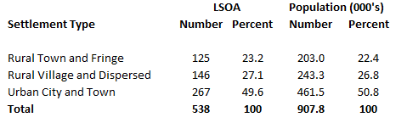
Key point:
- a small majority of the rural population of Norfolk is situated in LSOAs classified as Rural Village and Dispersed.

Table 7 Norfolk: The Distribution of IMD 2019 LSOA Ranks by Settlement Type
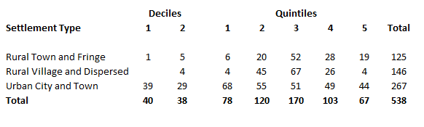
Key points

- the IMD identifies 10 out of 271 rural LSOAs as being in the top two deciles of deprivation and 1 in the most deprived decile,
- although small in number Rural Town and Fringe LSOAs occur most among rural ‘most deprived’ LSOAs,
- just under three quarters (71 percent) of ‘most deprived’ LSOAs are in the Urban City and Town category.

Table 8 Norfolk: The Distribution of RDI LSOA Ranks by Settlement Type
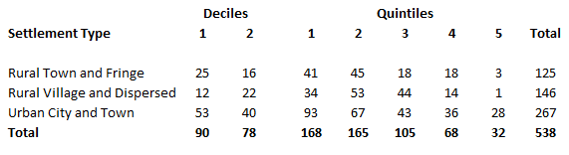
Key points:
- the RDI increases the number of LSOAs in the two most deprived deciles from 9 to 75,
- there is an increase of 35 ‘most deprived’ LSOAs among Rural Town and Fringe LSOAs and an increase of 30 in Rural Village and Dispersed LSOAs,
- the number of Urban City and Town LSOAs in the top two deciles is increased from 68 to 93 under the RDI,
- there is a marked shift from ‘less’ to ‘more’ deprived quintiles across all three rural and urban categories,
- the majority of the increase in ‘most deprived’ LSOAs occurs in the west of the county with some in the coastal east (Maps N1 and N2).

Table 9 Norfolk: Significant Shifts in Deciles from IMD to RDI

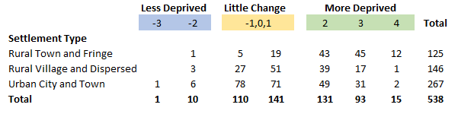

Key points:

- 157/271 rural LSOAs (57 percent) of rural LSOAs shift by 2 or more ranks in a ‘more deprived’ direction under the RDI.
- there is a shift of 82/267 (31 percent) of Urban City and Town LSOAs in a ‘more deprived’ direction,
- nearly twice as many Rural Town and Fringe LSOAs compared with Rural Village and Dispersed LSOAs shift by 2 or more deciles in a ‘more deprived’ direction (100 compared with 57),
- 4 rural LSOAs become less deprived,
- the few ‘most deprived’ LSOAs on the IMD are in the west of the County whereas those identified by the RDI are more scattered across the County (Maps N1 and N2).
- this pattern is broadly similar when the changes from IMD to RDI ranks are considered (Map N3).

Case Study 3: The County of Devon

Table 10 Devon: The Distribution of Numbers and Population of LSOAs by Rural Definition

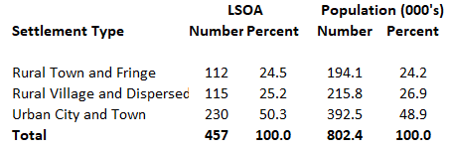
Key Points:
- a total population that is identified as marginally more rural than urban,
- a larger population situated in Rural Village and Dispersed LSOAs than Rural Town and Village.
- Devon has 39 LSOAs in a Sparse context with a total population of 83,800

Table 11 Devon: The Distribution of IMD 2019 LSOA Ranks by Settlement Type
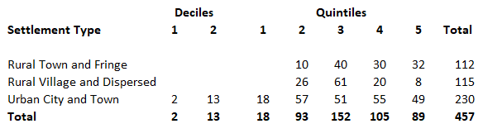
Key Points:
- no LSOAs identified as ‘most deprived (deciles 1 or 2) in the rural domain,
- the small number of ‘most deprived’ LSOAs (15/230) in the County are in the urban domain (i.e. the Urban Towns of Barnstaple, Bideford, Ilfracombe and Exeter (Map D1)

Table 12 Devon: The Distribution of RDI 2019 LSOA Ranks by Settlement Type
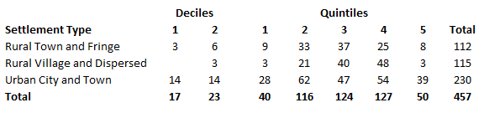 Key Points
- compared with the IMD 12 rural LSOAs move into Deciles 1 and 2 most (9) in the rural town and fringe group
- a further 13 Urban City and Town LSOAs move into the ‘most deprived’ group
- the ‘least deprived’ group (Quintile 5) reduces by 39 LSOAs,
- the few LSOAs in Deciles 1 and 2 on the RDI are mainly in the north and sparsely populated parts of the County (Map D2).

Table 12 Devon: Significant Shifts in Deciles from IMD to RDI

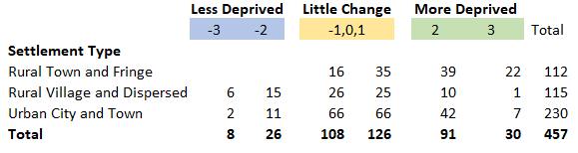

Key Points
- 71 rural LSOAs (31%) move 2 or more ranks in a ‘more deprived’ direction
- most of these (61) are Rural Town and Fringe LSOAs
- 49 Urban City and Town LSOAs (21%) shift by 2 or more ranks in a ‘more deprived’ direction
- 21 Rural Village and Dispersed LSOAs move into ‘less deprived’ but no Rural Town and Fringe LSOAs do so,
- rural LSOAs vary considerably in size and shape and are likely to contain settlements with widely varying levels of deprivation (Map D4).

6 The Case Studies, Some Points for Discussion.

The RDI provides a valuable counterfactual from which to explore some of the issues surrounding the apparent ‘bias’ towards the urban in the IMD and to examine the construction of a more rurally relevant indicator of deprivation. Recognising that the case studies are limited in number and that the method of IMD-RDI comparison is designed for transparency rather than statistical rigour, what do the results tell us? The following points (by no means exhaustive), might be a basis for discussion:

- there are increases in both RTF and RVD LSOAs in the ‘most deprived’ (Deciles 1 and 2) LSOAs between the IMD and the RDI in all three counties,

- in terms of numbers these increases are a particular feature of RDF LSOAs, especially in Lincolnshire and Norfolk and, to a lesser extent, in the Devon case,

- perhaps unexpectedly, the IMD-RDI comparison also identifies more Urban Town and City LSOAs especially in the Norfolk case but also, though with small numbers, in the Devon case,

- as regards shifts in rankings from IMD to RDI, these are significantly in the direction of ‘more deprived’ in all three counties and especially among RTF and UTC LSOAs,

- mapping of shifts among LSOA rankings indicate a spread of shifts across all three counties,

- closer examination of the Devon case reveals the impact of LSOA areal extent/shape on the identification of settlement related deprivation as shown in Map D4.

Finally, there are two general points to be made. First, the impact, as yet unknown, of Covid 19 mitigation measures on 2021 Census data may, in any event, lead to a need to rethink the content of the IMD. Secondly, the 2021 Census is likely to be the last carried out in the traditional questionnaire manner. Future censuses will be based upon administrative data which opens the possibility for more finely grained approaches to the identification of rural deprivation. Both of these tendencies suggest the need for more local knowledge as input to any future indicator of rural deprivation.

Shepherd J ‘An Initial Analysis of the Rural Deprivation Index with respect to Lincolnshire’, February 2012.
The first analysis was undertaken at the suggestion of Ivan Annibal of Rose Regeneration. Ivan has provided support for the present extension of the research.
There are 32,844 LSOAs in England. On average they cover areas with around 1,500 residents or 650 households.
This would appear to leave seven variables for inclusion in the data aggregation model, four of which were from IMD 2015.
These few sentences do not by any means do justice to the careful sensitivity and validity testing procedures described in the paper. A full comparison of the potential role of the RDI compared with the IMD in policy applications would require careful assessment of these sections of the NMS paper.
Though in fact, nearly a decade after they were modelled the 2019 populations of LSOAs in Lincolnshire range from 1017 to 4575 with a mean of 1812. The unweighted mean between the three categories of settlement remains similar at about 1800.
Note that these distributions are for the RDI based upon the IDM 2019 data as kindly supplied by the authors of the NMS a paper.

